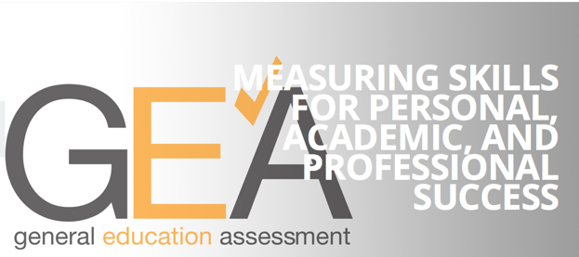
Paradise Valley Community College (PVCC) aspires to be the higher learning organization of choice by creating engaging lifelong educational relationships that inspire and support all learners to increase their capacity for personal growth and positive social change.
PVCC aspires to be a learning-centered college. A learning-centered college ensures that:
- Learning outcomes that create substantive change in learners are identified and made explicit. These outcomes drive course, program, and curriculum development as well as delivery of student, academic, and administrative support services.
- Learning outcomes are assessed for the purpose of demonstrating that learning occurred and to expand and improve learning.
- Learning opportunities are accessible to learners and offered in a variety of formats and options.
- A culture of student success exists: student success outcomes emphasize active and engaged learning, connecting to the college environment, goal setting, successful navigation of college processes, and relationship building with faculty, staff, students and peers. These outcomes are made explicit to students.
Discussion Questions: What are you doing to involve students in general education assessment? How do you inform them of the importance of general education?
-------------------------------------------------------------------------------------------------------------------------------------Remember the acronym PVCC to make GEA learning outcomes explicit to students.
P Provide the GEA Rubrics, course competencies, and learning outcomes for assignments. Also, provide feedback as part of formative assessment to help students improve.
V Validate the significance of general education, model general education abilities, and help students understand that improvement is obtainable and that students play a vital role in assessing their own knowledge and skills.
C Communicate information about assessment and describe related GEA abilities in the syllabus, talk to students about your assessment projects, and share the results.
C Connect assignment objectives to GEA outcomes, connect GEA abilities to the needs and interests and of the students, to real world situations, to other disciplines, and to the students’ past, present, and future experiences.

