Balance Exercises
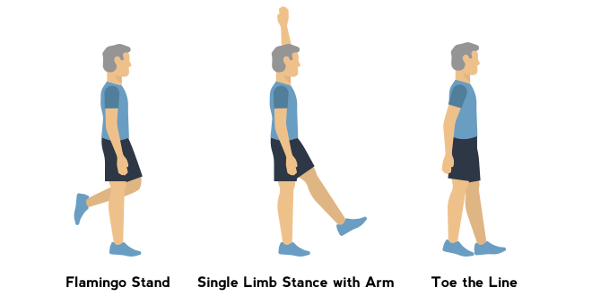
Flamingo Stand
- Stand with feet together and arm relaxed at sides. Hold onto a chair for support if needed.
- Bend one knee to lift the foot slightly off the ground and balance with your other leg.
- Hold for 10 seconds and repeat with other leg.

Single Limb Stance With Arm
- Stand with feet together and arm relaxed at sides. Hold onto a chair for support if needed.
- Raise your left arm overhead and raise your left leg forward and off the floor.
- Hold for 10 seconds then repeat on other side.

Toe the line
- Stand with arms relaxed at sides.
- Move one foot forward, placing the heel of one foot touching or as close as possible to the toes of your other foot. Repeat for 15-20 steps.
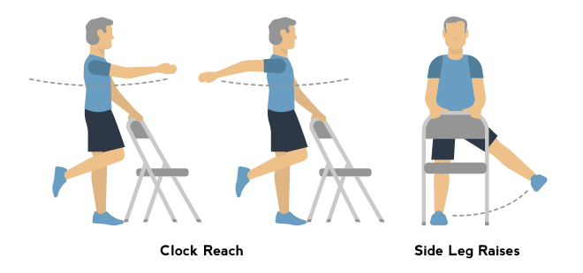
Side Leg Raises
- Stand behind a chair or counter with one or both hands using resting on it for support.
- Lift your right leg out to the side and repeat 10 times for each leg.
Clock Reach
- Begin standing, holding a chair with your left hand. Imagine a clock with 12 o’clock in front of you and 6 behind.
- Stand on your left leg, bring your right arm to 12 o’clock and reach to 3 o’clock to your side, and 6 o’clock towards the back. Repeat with other side.

