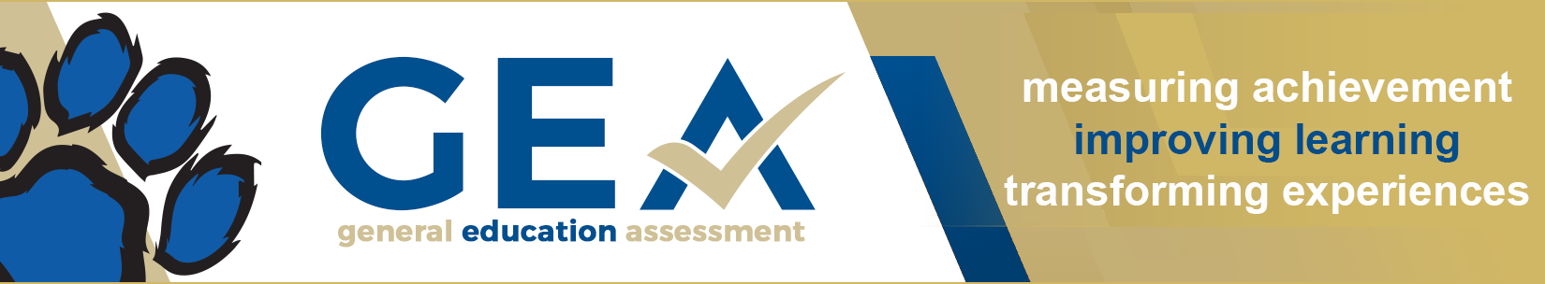

How to Identify Specific Learning Outcomes
There are many learning outcomes to measure, including Institutional Learning Outcomes (General Education Assessment GEA Rubrics), Program Learning Outcomes, and Course Learning Outcomes. It has the potential to become a complicated and at times, confusing process. But we can improve that process by making it more functionally for faculty and more interconnected for students by linking multiple outcomes in a single assessment project. This activity will help guide you through the process of selecting specific learning outcomes.

Step 1: Choose one course that you teach this Fall.

Course Name/Prefix:
Section #:

Step 2: Identify Specific Student Learning Outcomes:

Option A: General Education Assessment (GEA) PVCC Institutional Learning Outcomes
Review the GEA Rubric packet and identify a specific dimension from one of the nine rubrics to measure. Link to GEA Packet: https://cdn.paradisevalley.edu/docs/employees/al/al-gea-packet.pdf
Copy and paste the specific GEA outcome(s) here:

Option B: Program Learning Outcome
Identify the MCCCD Official Program Outcomes most related to that course.
Here is the link to the Program Search. Find the most related program, it’s credential, and then scroll to the “What You Will Learn” section.https://www.maricopa.edu/degrees-certificates#programs-by-name
Copy and paste the Program Outcome(s) here:

Option C: Course Competency (Course Learning Outcome)
Identify the MCCCD Official Course Competencies for the Course from the Center for Curriculum and Transfer Articulation. Here is the link to the CCTA Course Search: https://curriculum.maricopa.edu/course
Copy and Paste the Course Competencies here:

Step 3: Look for connections or overlapping skills that exist between the course competencies, program outcomes, and GEA Rubric dimensions. Attempt to identify a relationship between 1-2 specific learning outcomes

Show the connection here:

Step 4: Brainstorm a project or activity that can be used to measure both the program and course outcomes simultaneously. What is the best evidence that students are achieving these outcomes? How will you know that students possess the knowledge or can demonstrate the abilities listed in the outcomes? Will you use a test question, essay, presentation, case study…to measure achievement of the outcome? Hint: You will need to measure the outcomes at least twice to complete the assessment process (Assess, Intervene, Reassess).

Step 5: Transfer these details to part 1 of the assessment form in the GEA Online Tool. Here is the link: https://community.paradisevalley.edu/gea30/

Resources:
CCTA https://curriculum.maricopa.edu/

